Eigen Faces is one of the old techniques for face recognition which is dependent on PCA.

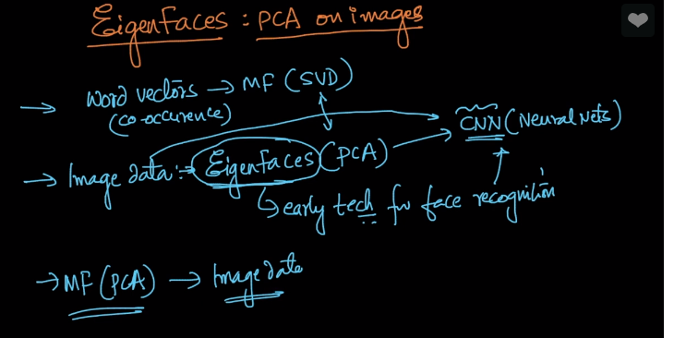

We don’t use Eigen Faces today but it is good to have glance about old techniques which were used.

So we will take an dataset which consist of 400 images where each image is 64*64 pixel size.

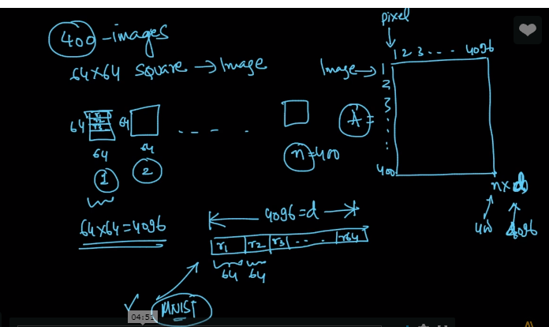

We can flatten each image in single row and then form a matrix which will be our final data for analysis and we will perform PCA on it.

So this is how it will look like when we apply PCA to this data.

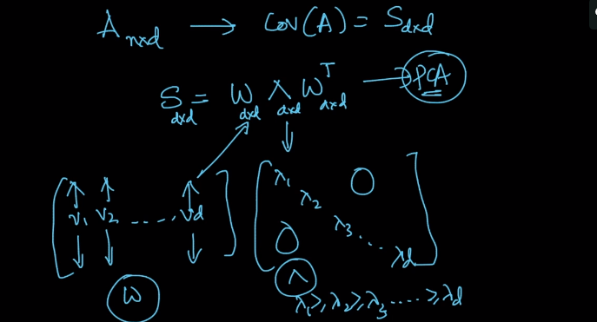

Now what we learnt in dimensionality reduction chapter we will reduce the dimension from d to k.

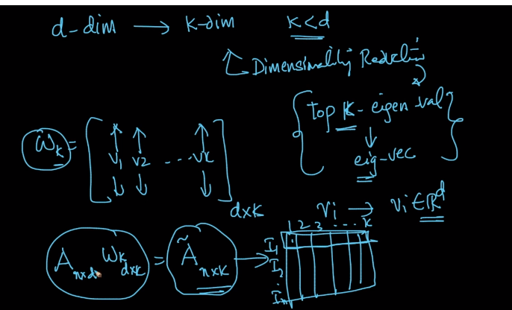

And we will get A~(n*k) matrix.

And now when we get d*k matrix so each vector is actually length 64

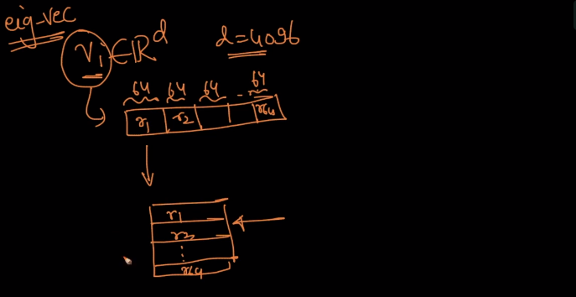

And so we can now again reform row to column and it will be our face but with reduced dimension which will look like as shown in below image.

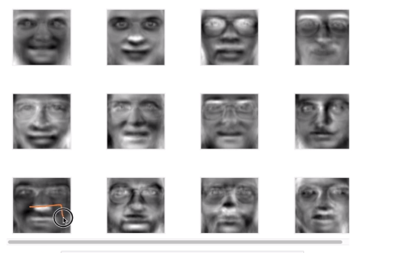

Below graph shows amount of variance explained

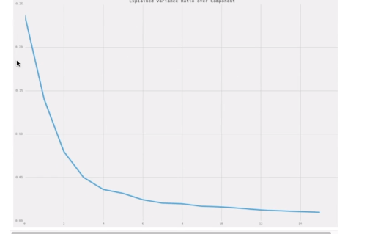

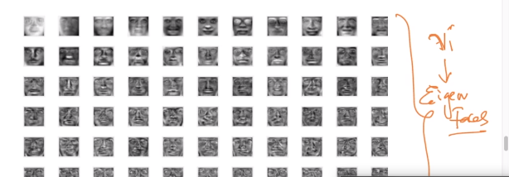

**Link to above tutorial:**

[**https://bugra.github.io/work/notes/2014-11-16/an-introduction-to-unsupervised-learning-scikit-learn/**](https://bugra.github.io/work/notes/2014-11-16/an-introduction-to-unsupervised-learning-scikit-learn/)